Febal Casa - Miami

Editorial Coverage Clippings
Table of Contents
Media // Inside Retail US - November 25, 2024 2
Media // Miami Living Magazine - November 22, 2024 3
Media // BELLA Magazine - November 22, 2024 7
Media // OK! Magazine - November 22, 2024 10
Social // Patrick Van Negri - November 22, 2024 11
Social // Sandra Augustin - November 21, 2024 12
Social // Julie Leonardi - November 21, 2024 13
Social // Bridgette Matter - November 21, 2024 14
Social // Suraia Patricia - November 21, 2024 15
Media // PR Newswire - November 21, 2024 16
Media // The Real Deal - November 18, 2024 18
Media // Miami Living Magazine - November 15, 2024 19
Media // South Florida Business Journal - November 7, 2024 23

Media // Inside Retail US - November 25, 2024
- Inside Retail US: Febal Casa enters US, opens flagship showroom in Miami - Inside Retail US (UVM: 59,035) - November 25, 2024


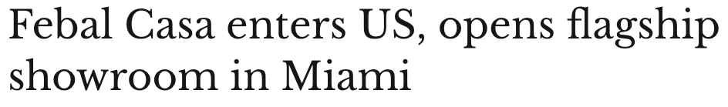
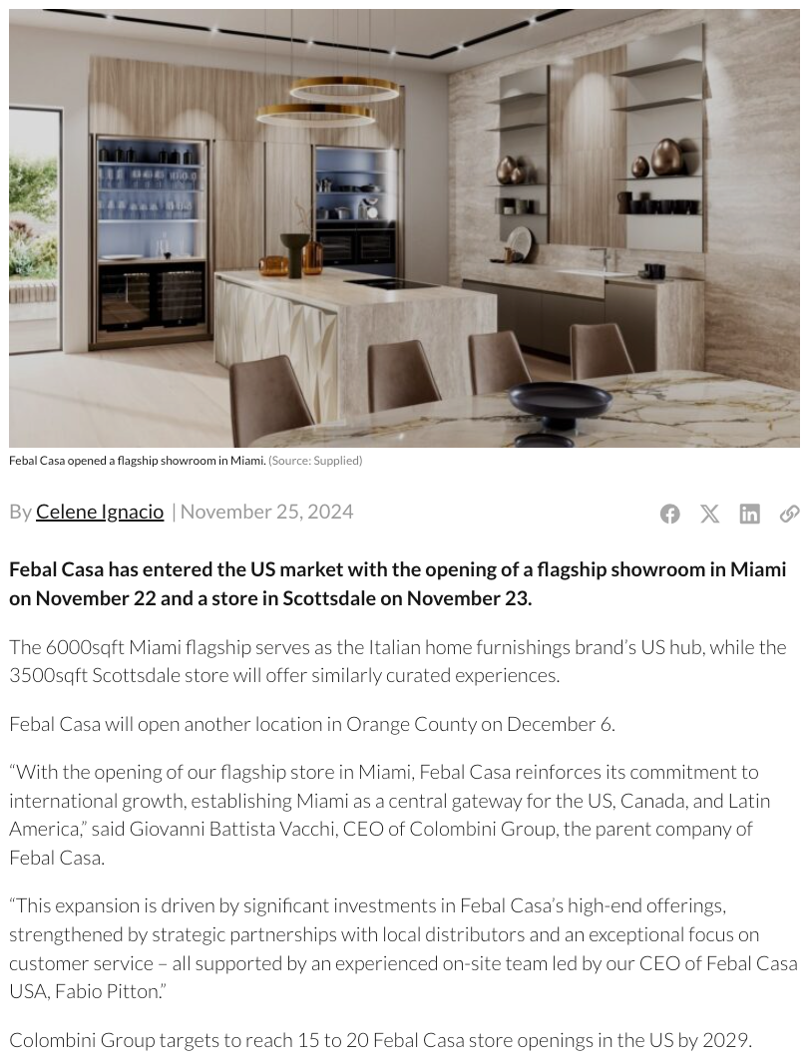

Media // Miami Living Magazine - November 22, 2024
- Miami Living Magazine: Italian Design Brand Febal Casa Opens Flagship Showroom in Miami's MiMo District (UVM: 13,245) - November 22, 2024


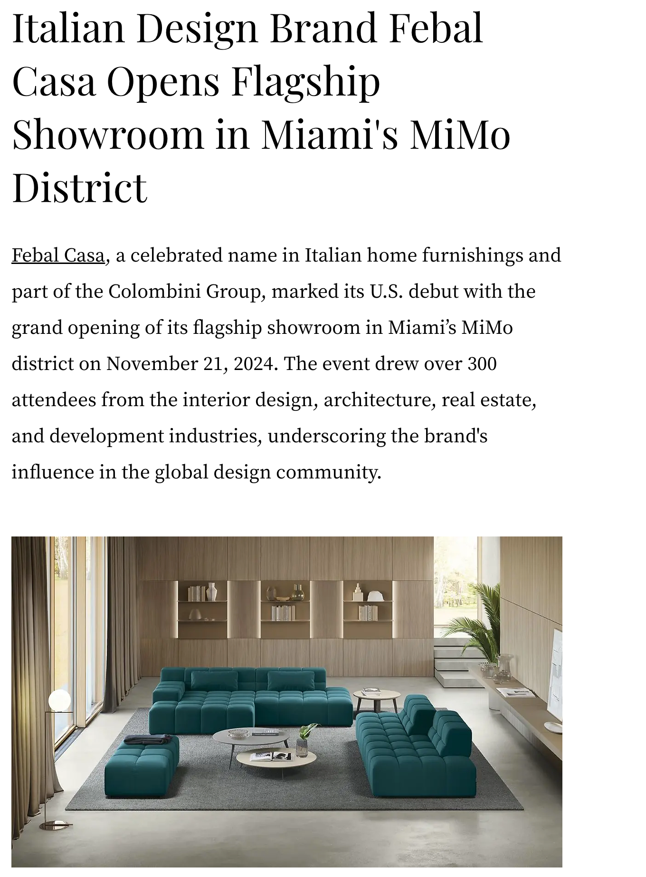
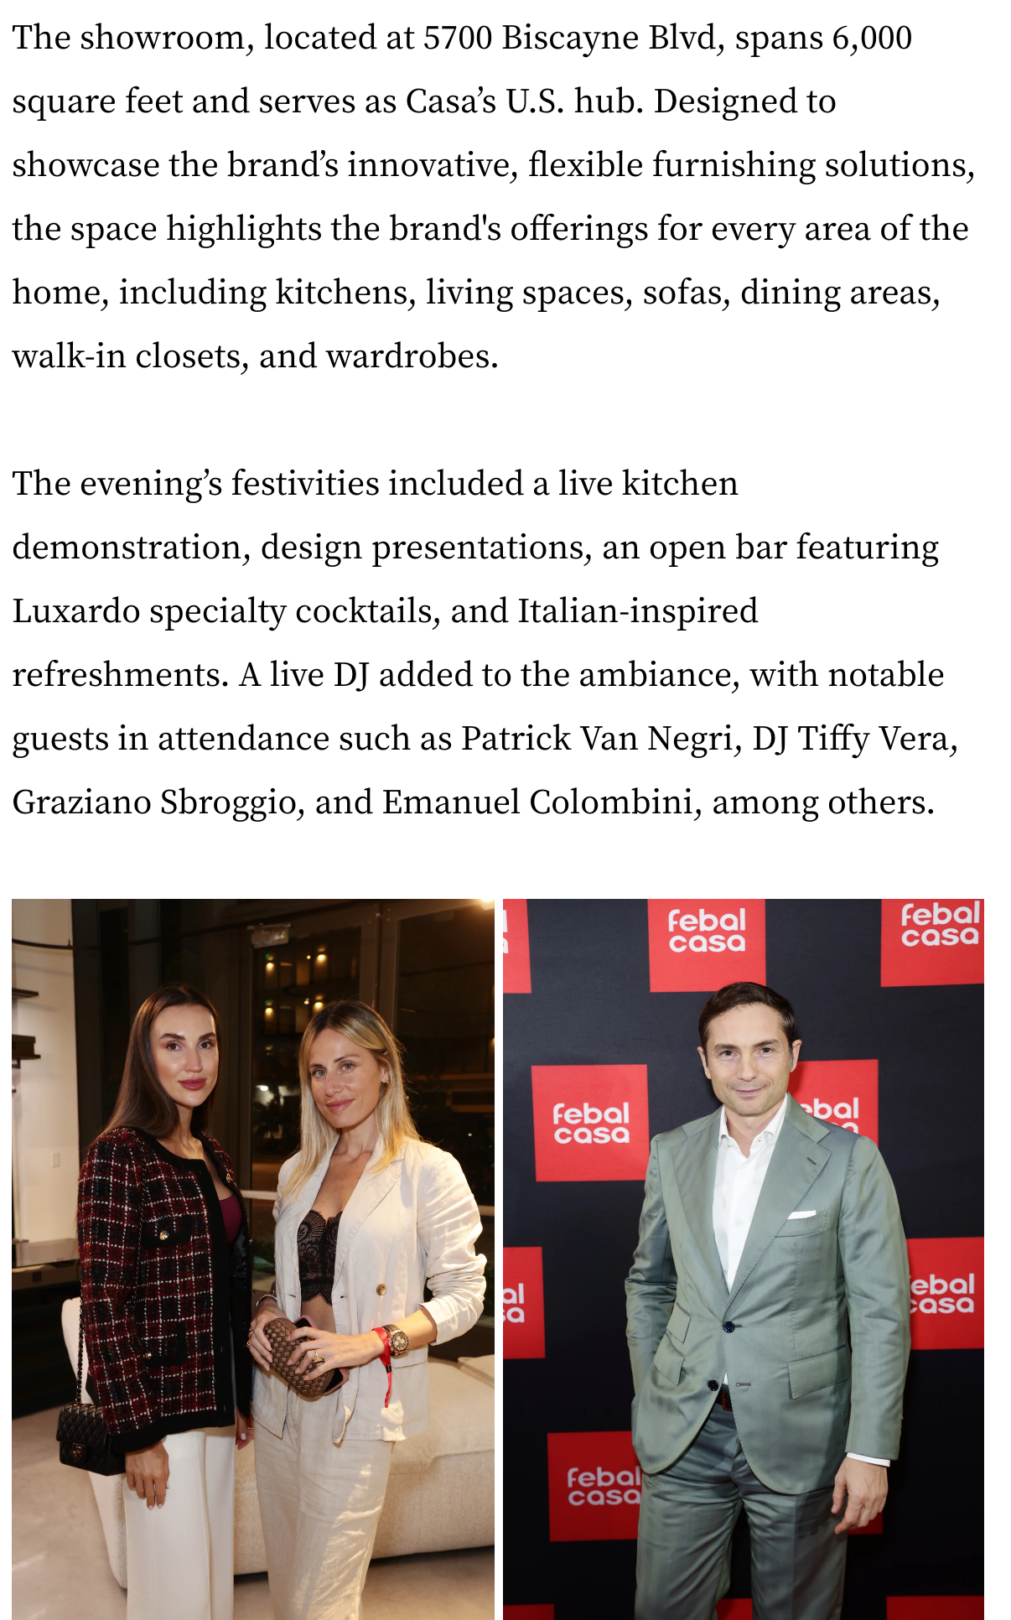

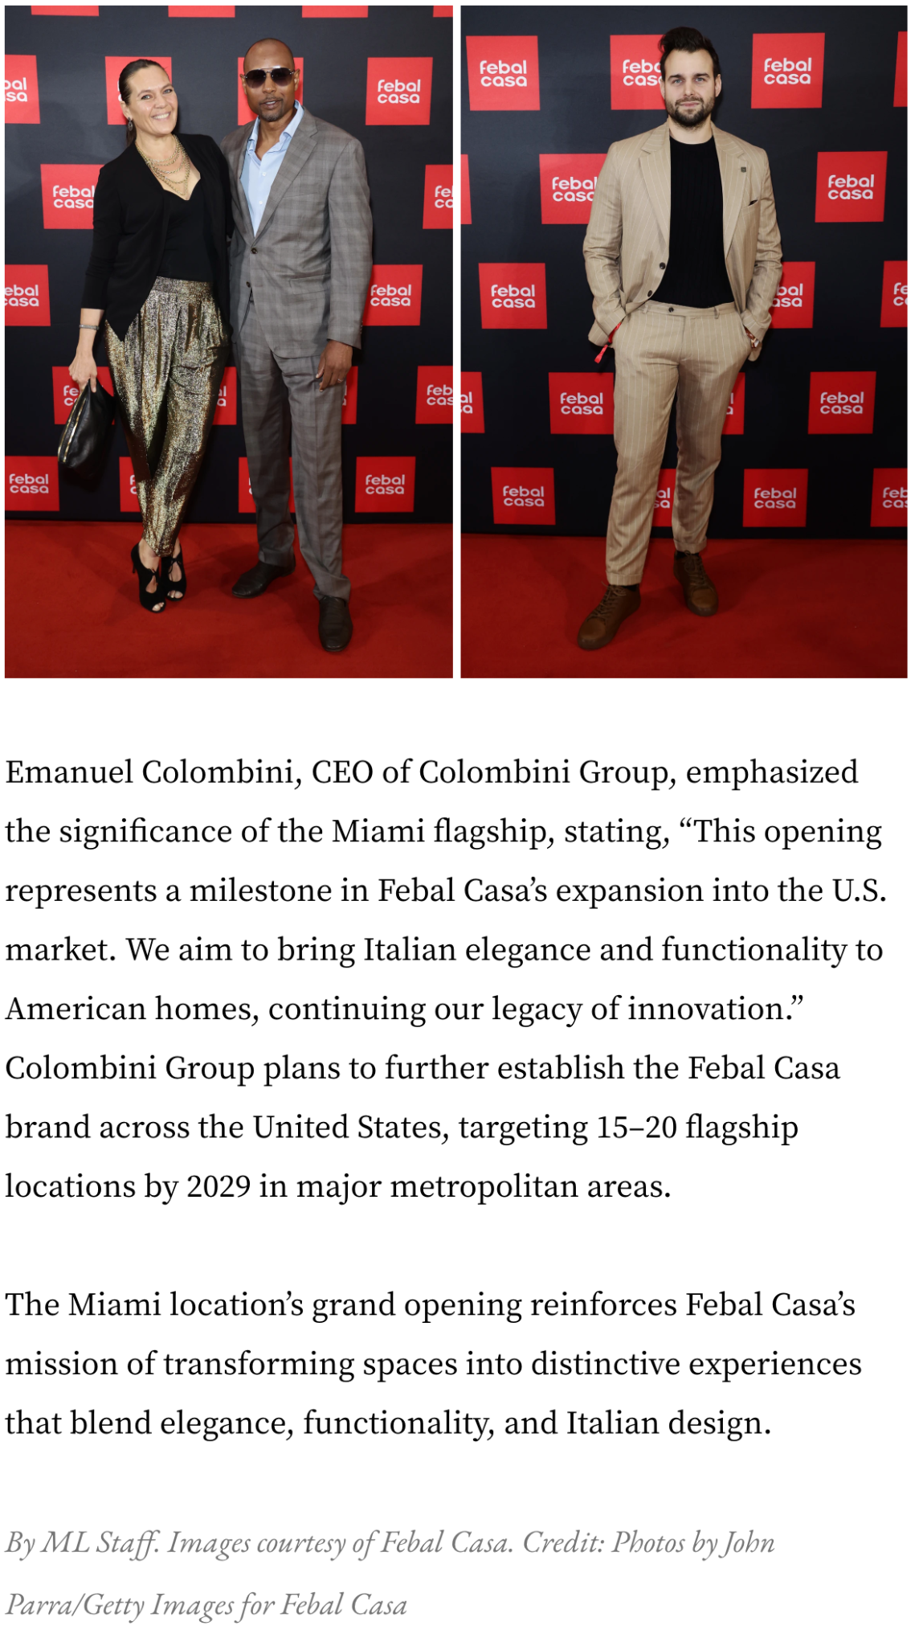

Media // BELLA Magazine - November 22, 2024
- BELLA Magazine: Febal Casa Enters U.S. Market with Flagship Store Opening in Miami (UVM: 450,000) - November 22, 2024




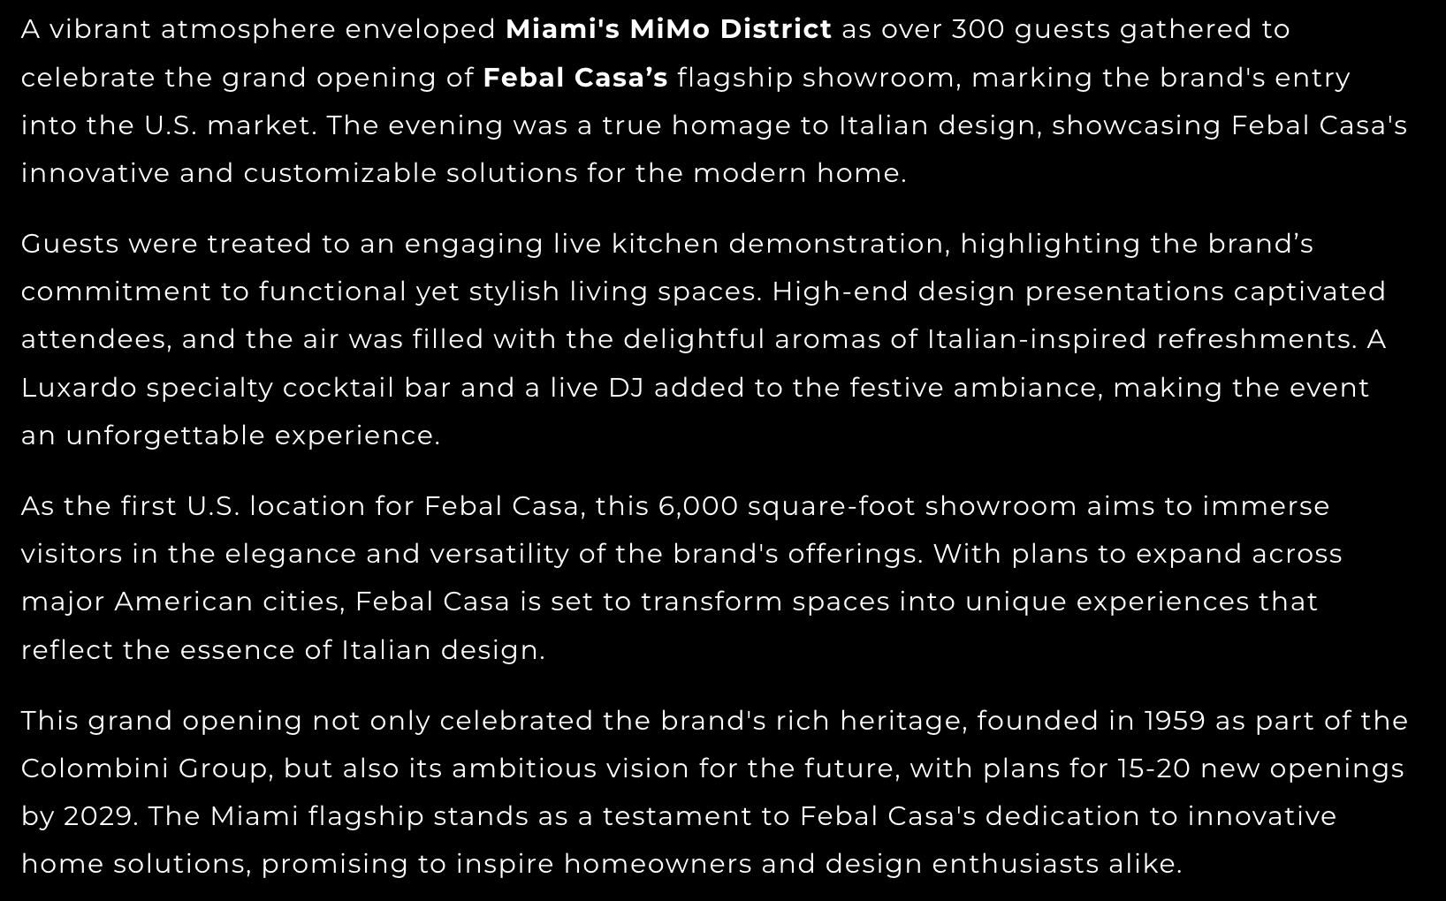
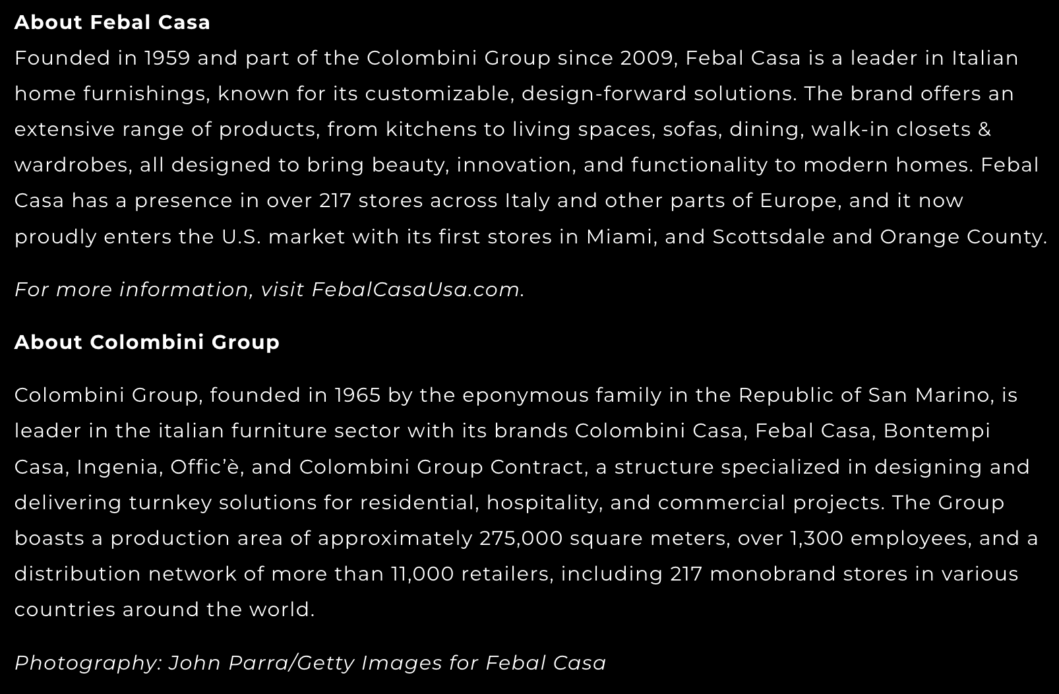


Media // OK! Magazine - November 22, 2024
- OK! Magazine: HOT PICS! DJ Tiffy Vera spins at the Febal Casa U.S. flagship showroom grand opening in Miami's vibrant MiMo District on Thursday, November 21 (UVM: 2,343,543) - November 22, 2024


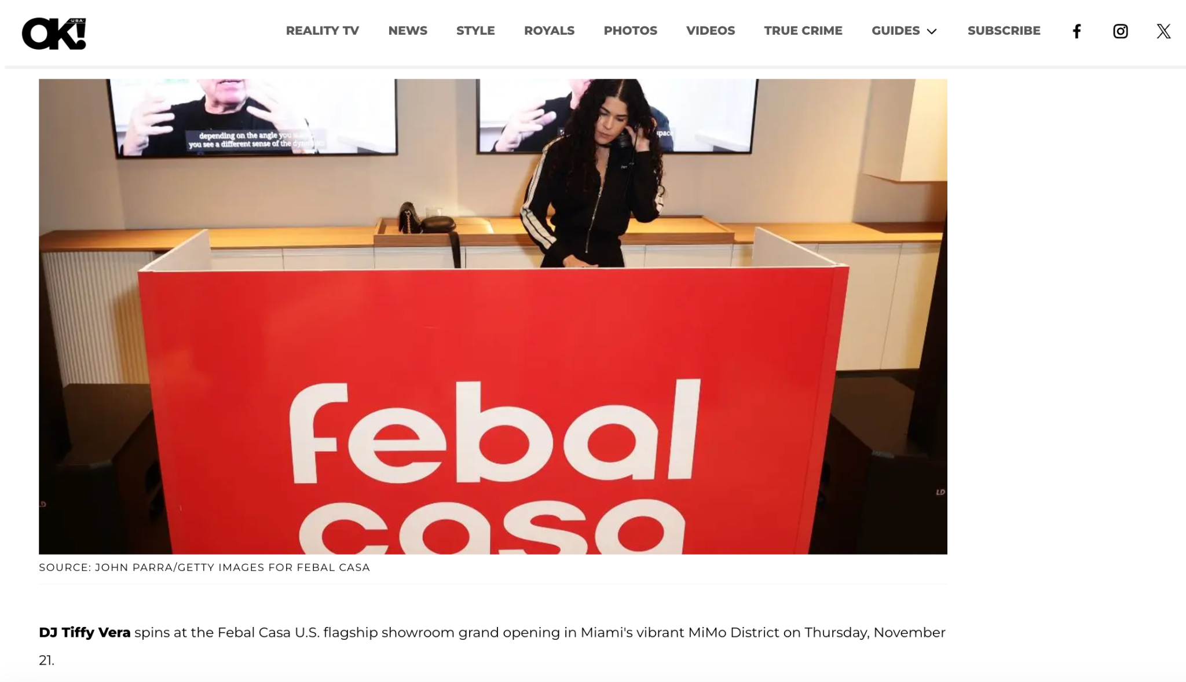

Social // Patrick Van Negri - November 22, 2024
- Patrick Van Negri, @patrickvannegri Instagram Stories (Followers: 11.9K) - November 22, 2024


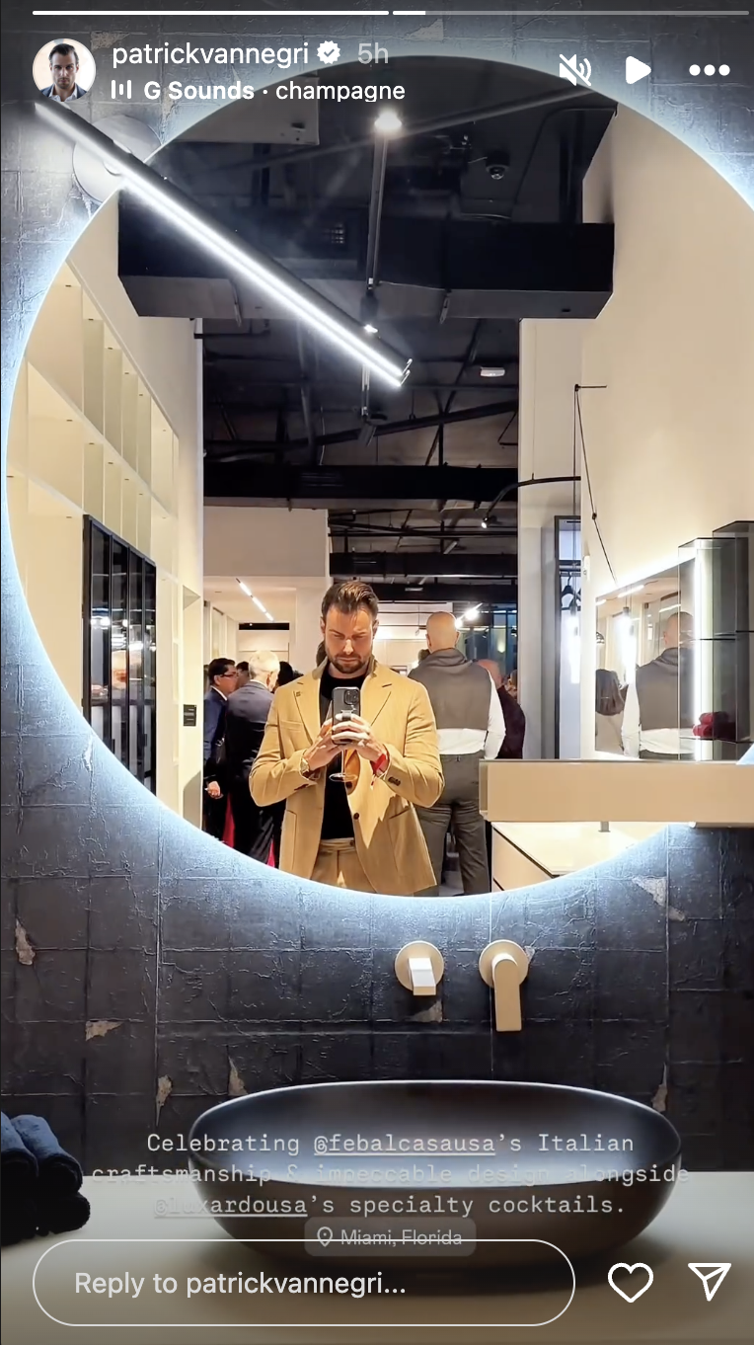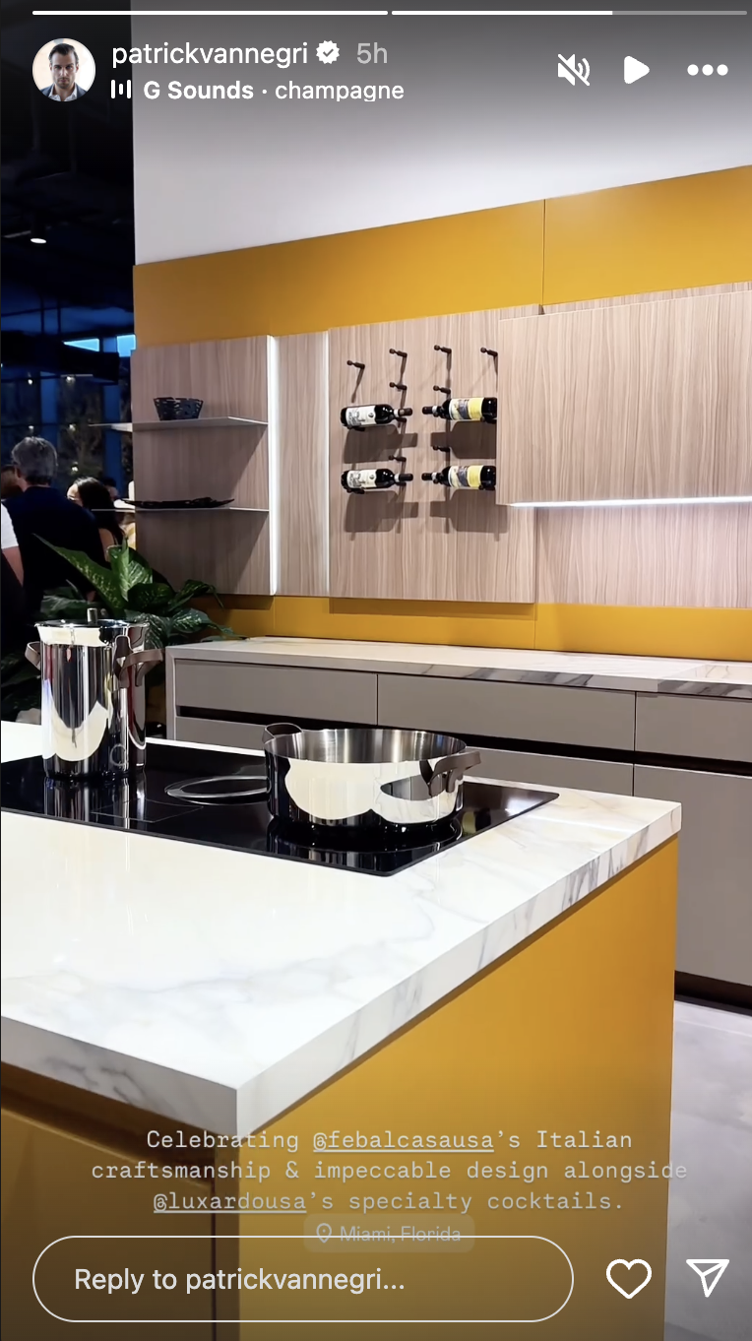

Social // Sandra Augustin - November 21, 2024
- Sandra Augustin, @classicwoman Instagram Stories (Followers: 32.6K) - November 21, 2024
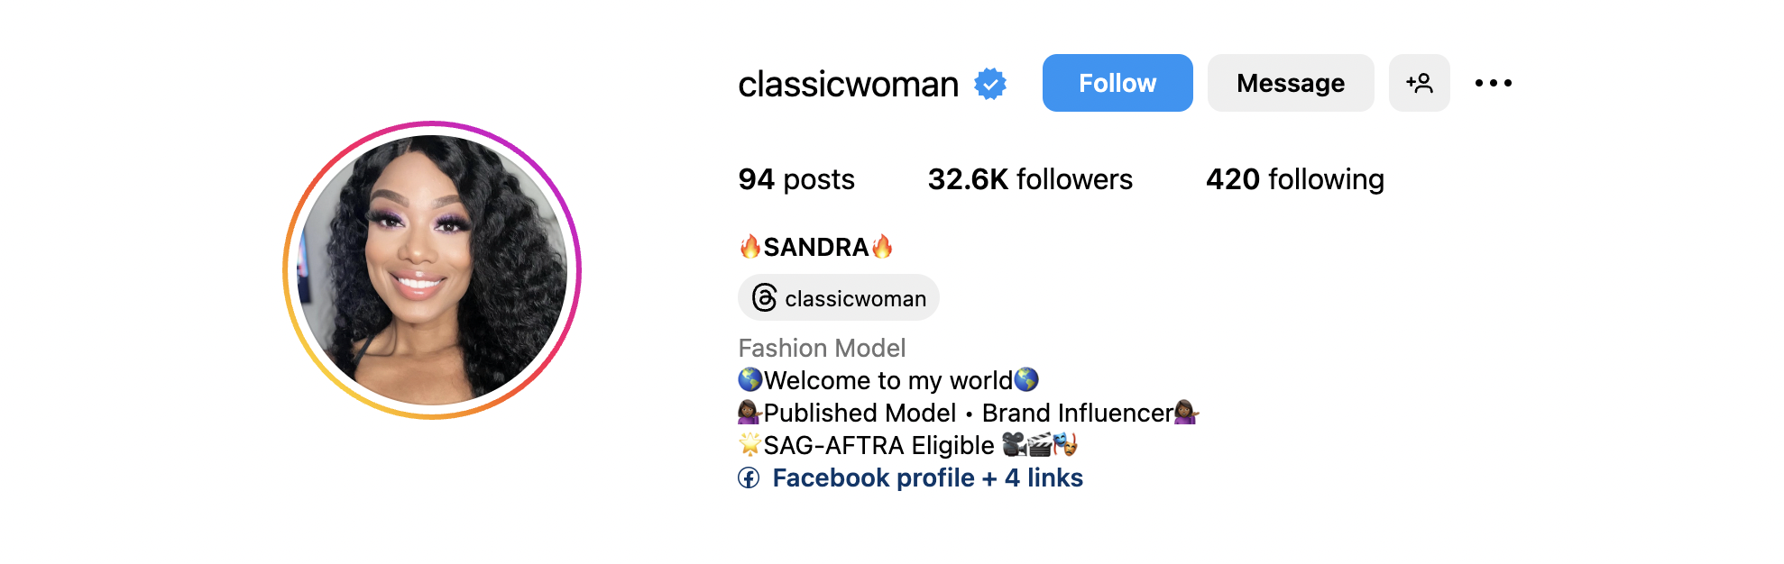
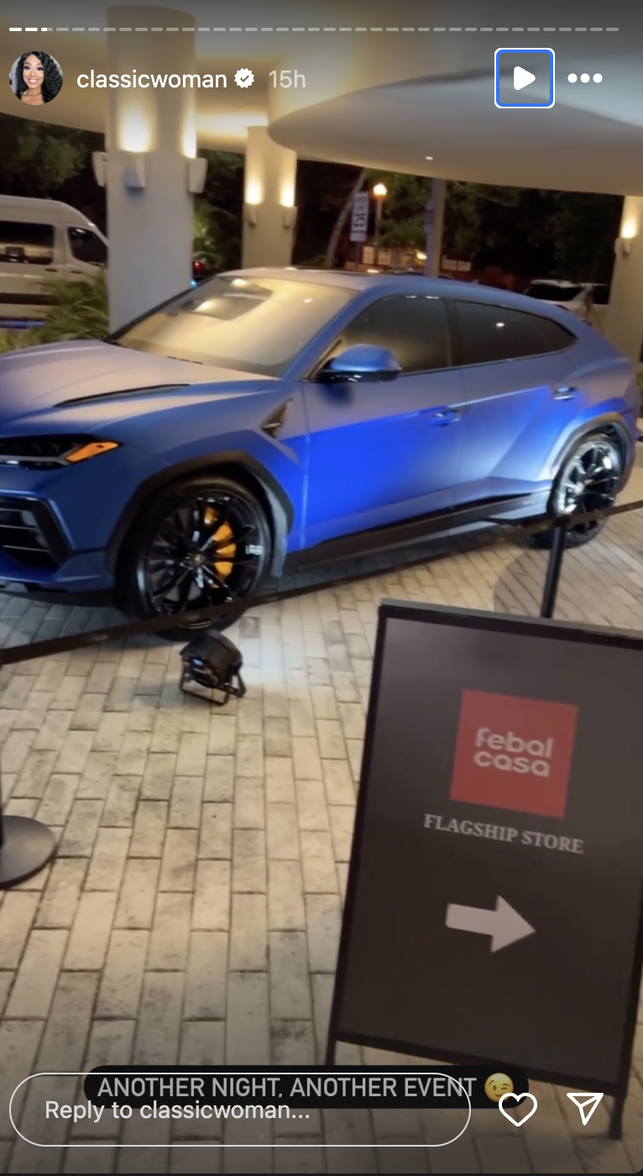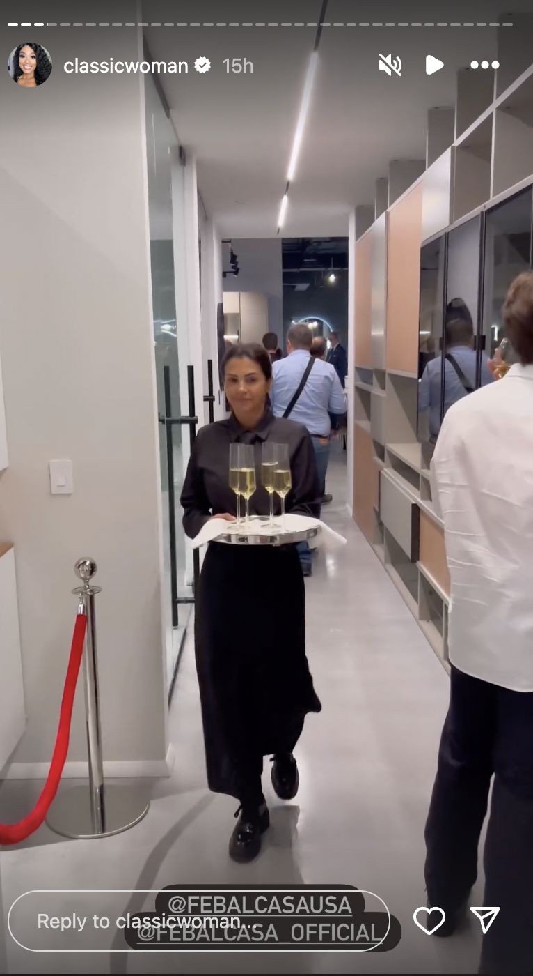
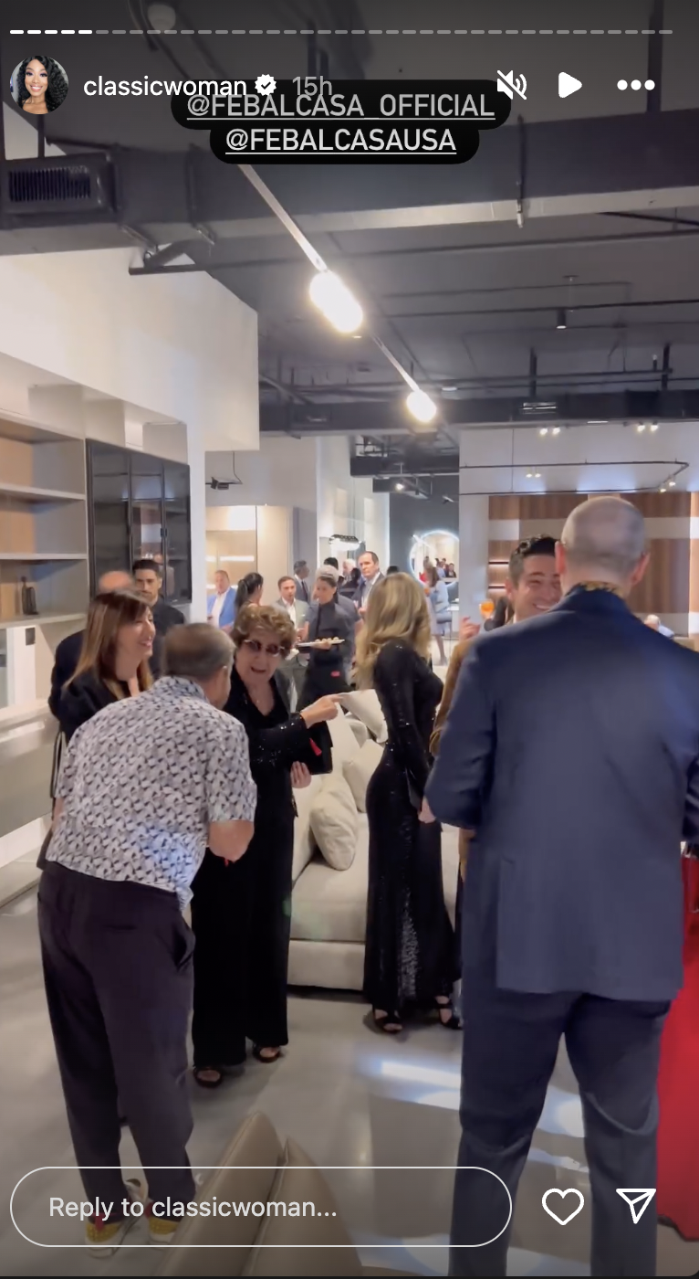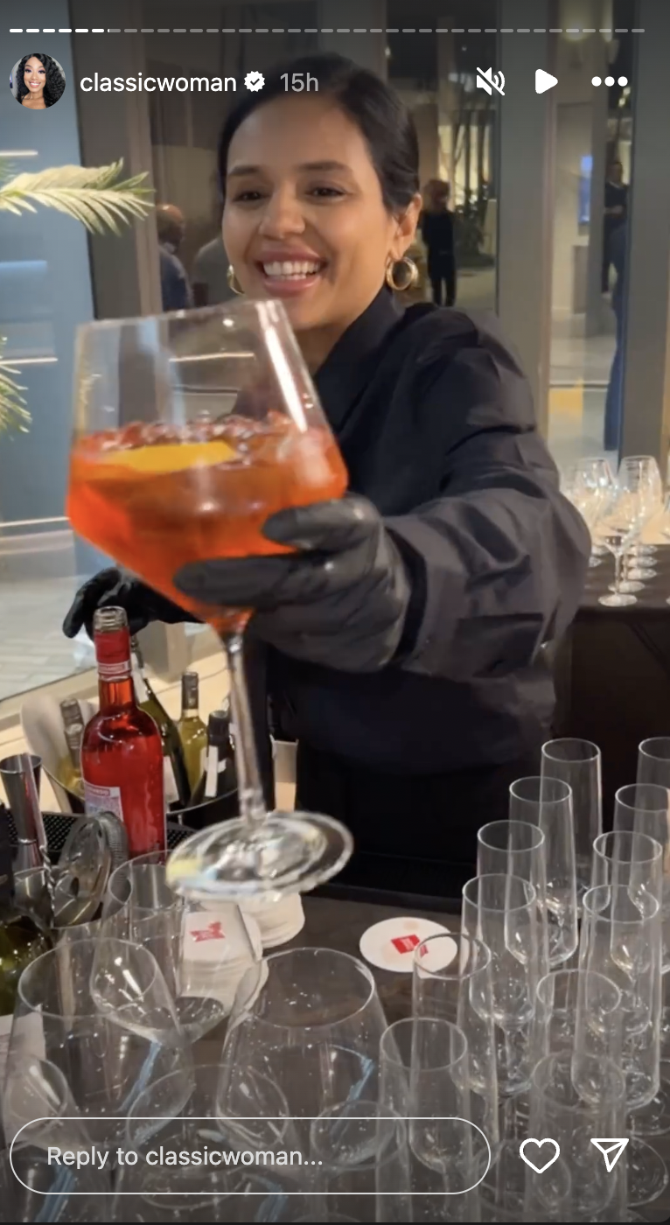

Social // Julie Leonardi - November 21, 2024
- Julie Leonardi, @julieleonardi Instagram Stories (Followers: 2,741) - November 21, 2024


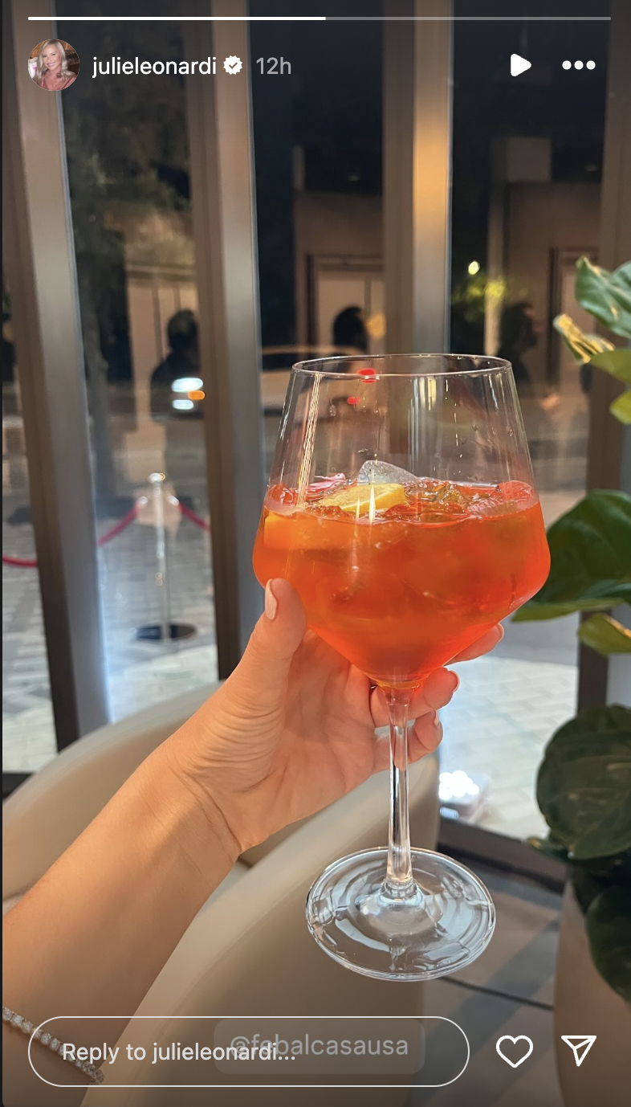

Social // Bridgette Matter - November 21, 2024
- Bridgette Matter, @bridgettemattertv Instagram Stories (Followers: 14.4K) - November 21, 2024


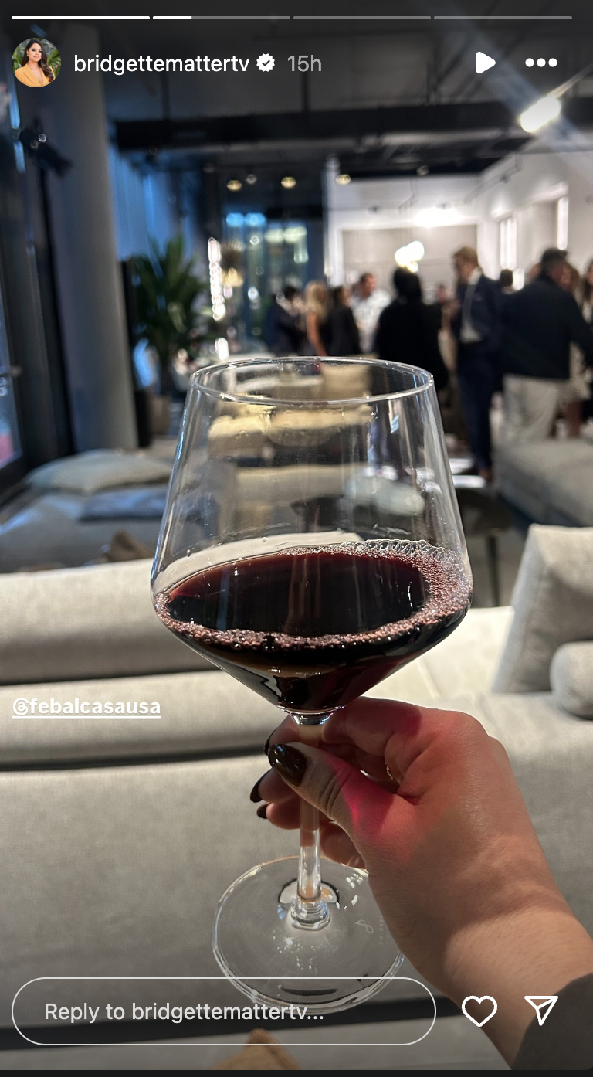

Social // Suraia Patricia - November 21, 2024
- Suraia Patricia, @suraiapatricia Instagram Stories (Followers: 5,496) - November 21, 2024
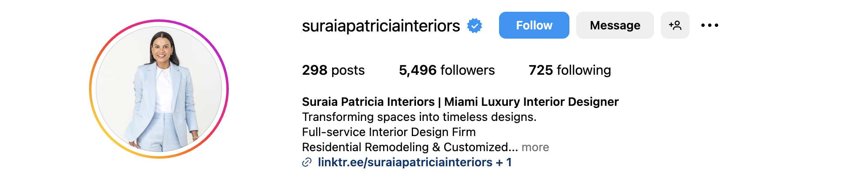
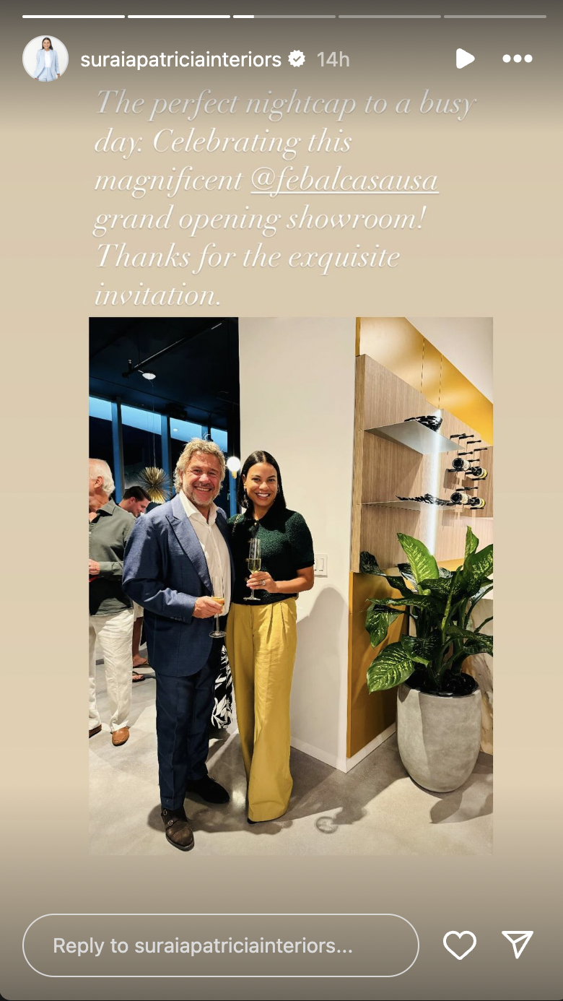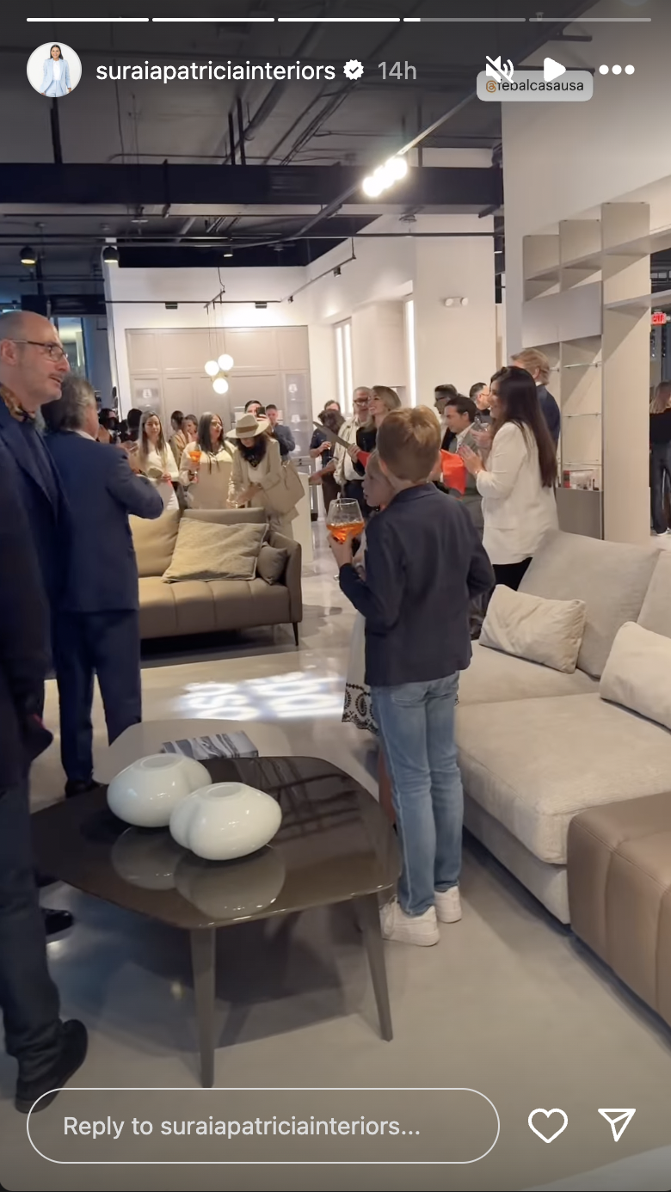

Media // PR Newswire - November 21, 2024
- PR Newswire: Febal Casa Enters U.S. Market with Flagship Store Opening in Miami and Outposts in Scottsdale and Orange County (UVM: 3,557,469) - November 21, 2024
  - Associated Press (UVM: 48,045,067)
  - Yahoo! Finance (UVM: 46,518,831)
  - Benzinga (UVM: 9,963,602)
  - StreetInsider (UVM: 399,664)

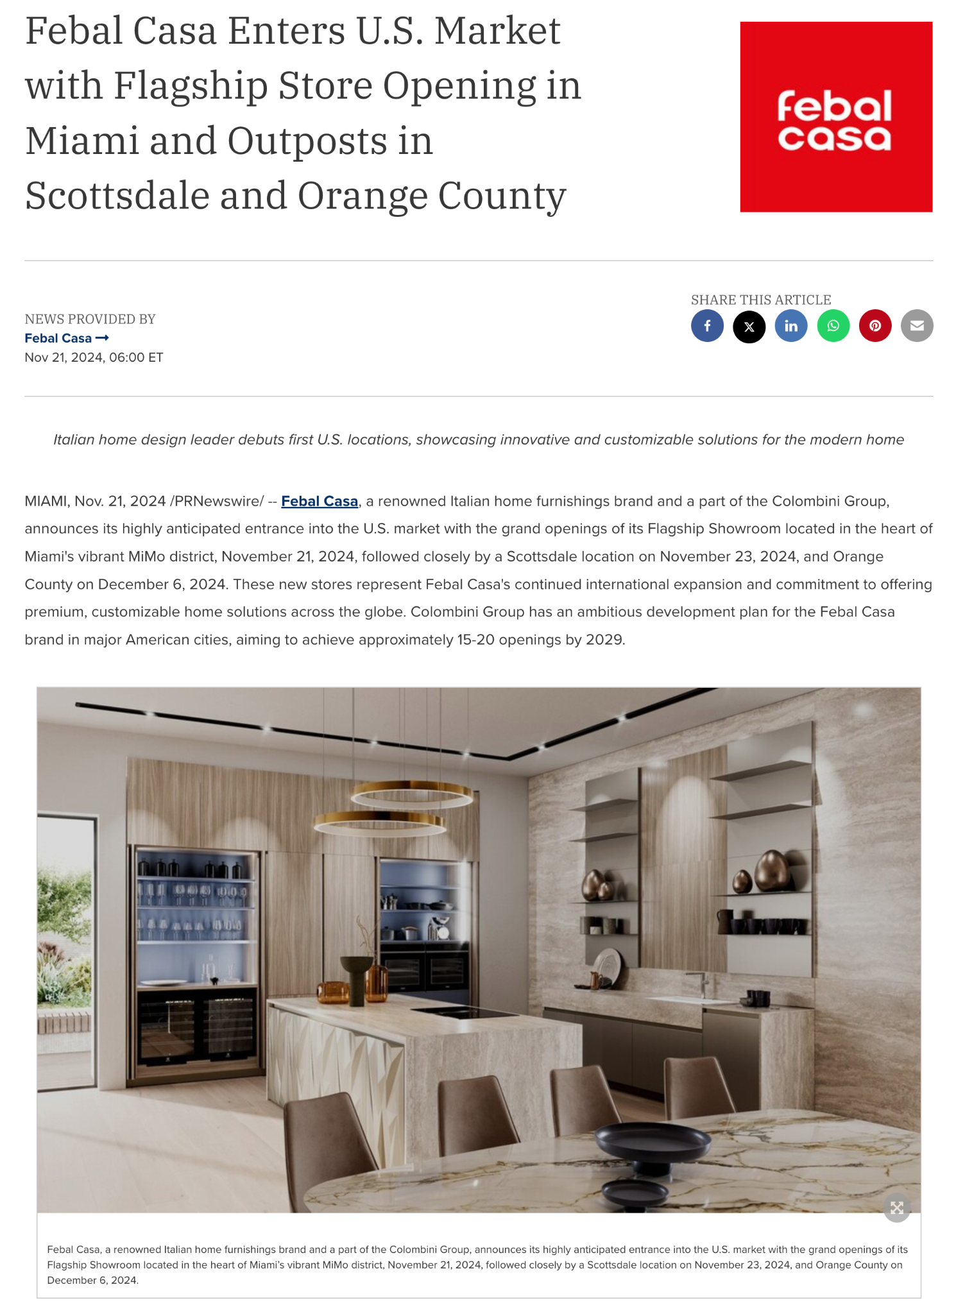
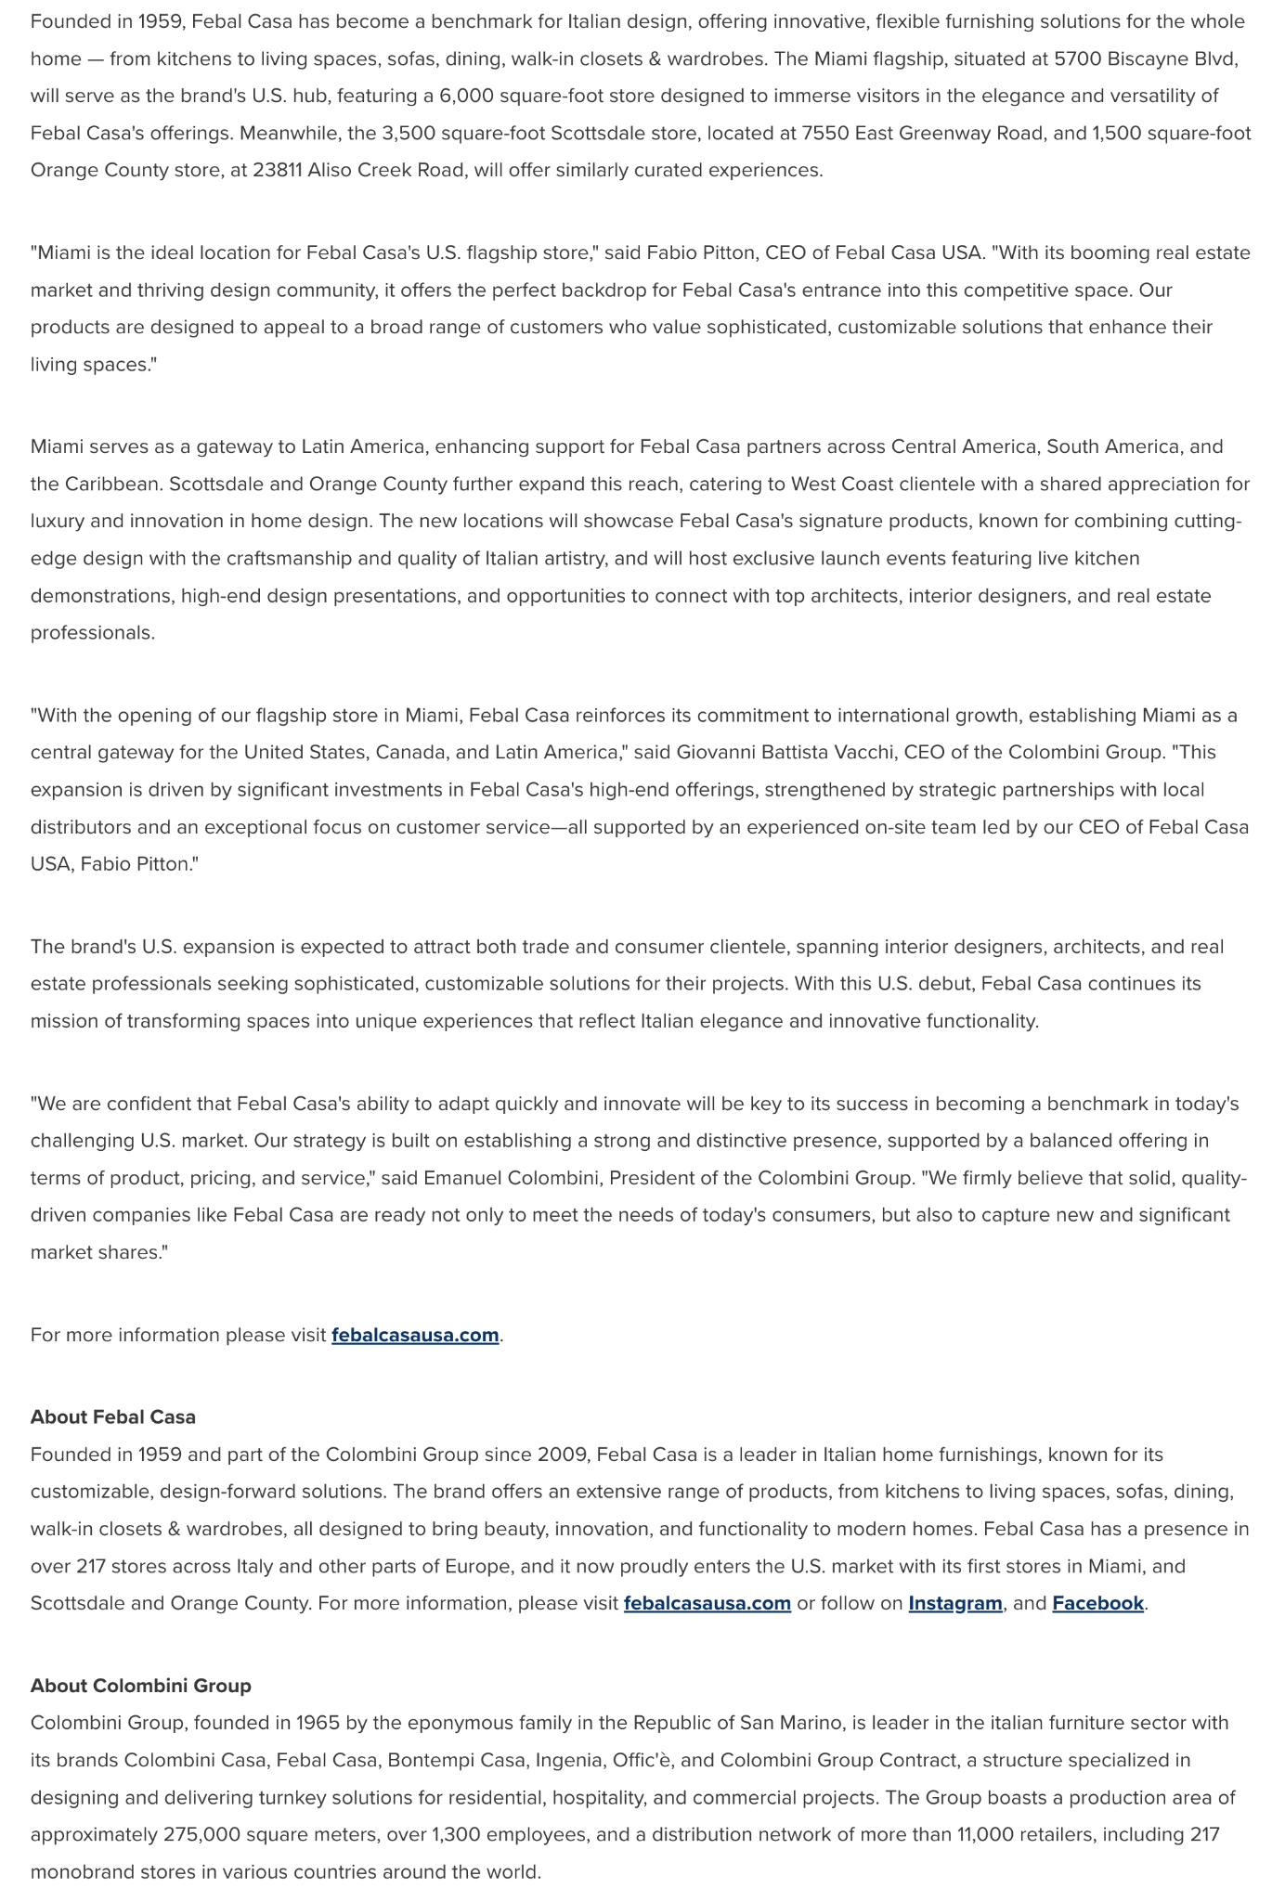

Media // The Real Deal - November 18, 2024
- The Real Deal: Lease roundup: Consultancy moving HQ from Las Vegas to Miami, Northbridge Centre now 95% leased (UVM: 9,732,299) - November 18, 2024


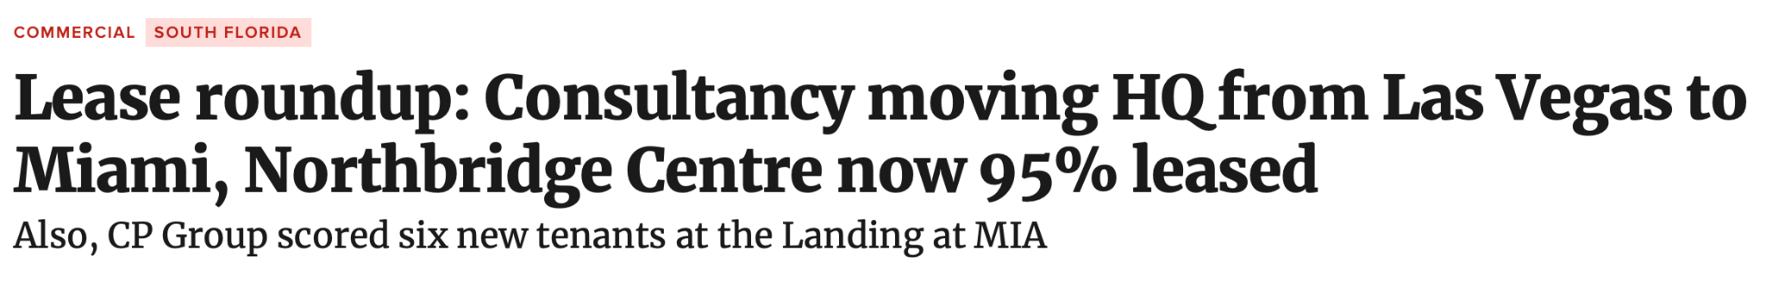
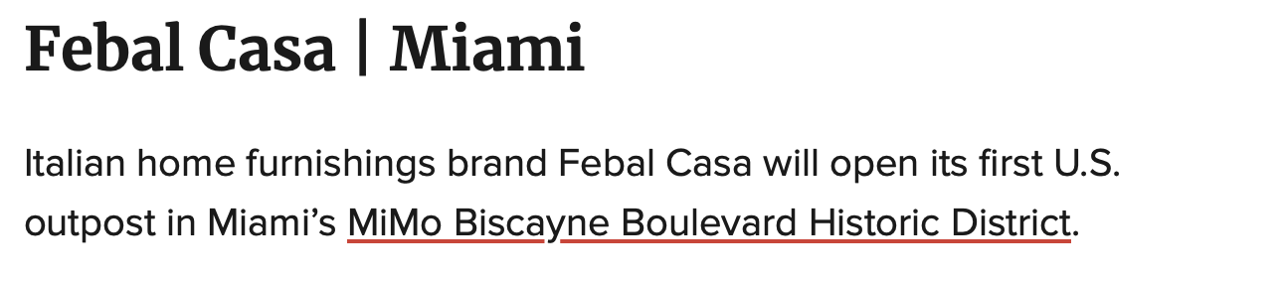
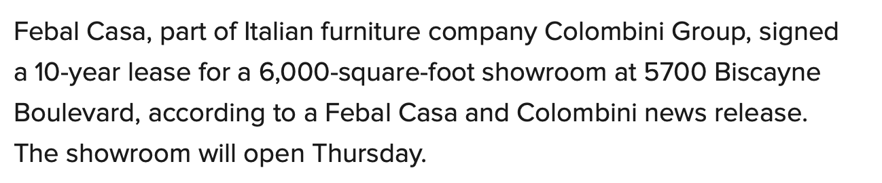
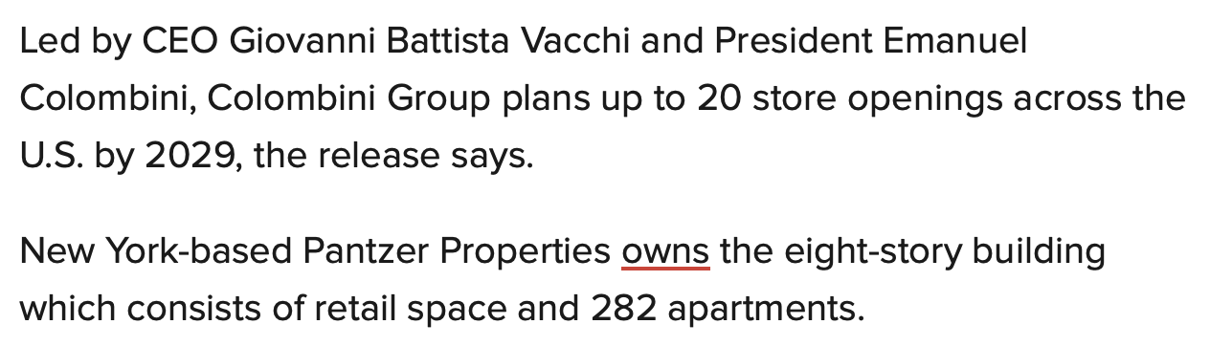

Media // Miami Living Magazine - November 15, 2024
- Miami Living Magazine: Febal Casa Expands to U.S. with Flagship Showroom in Miami and Additional Locations (UVM: 13,245) - November 15, 2024
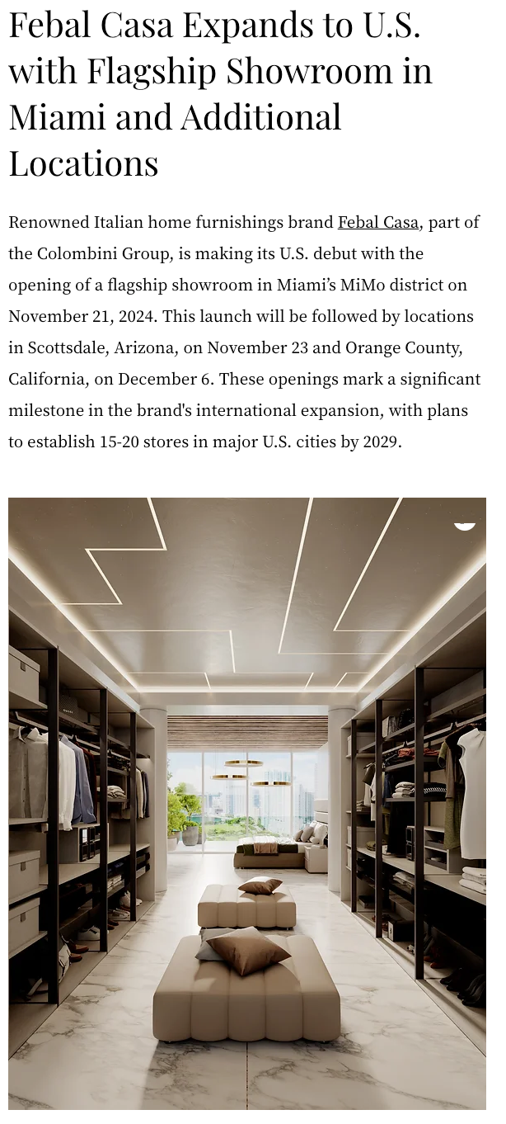

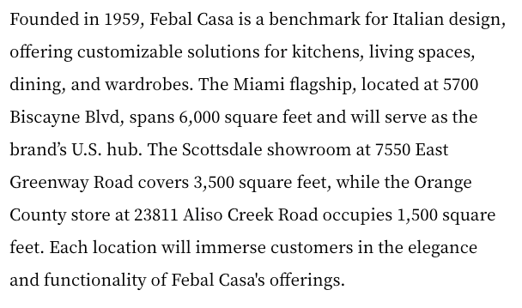

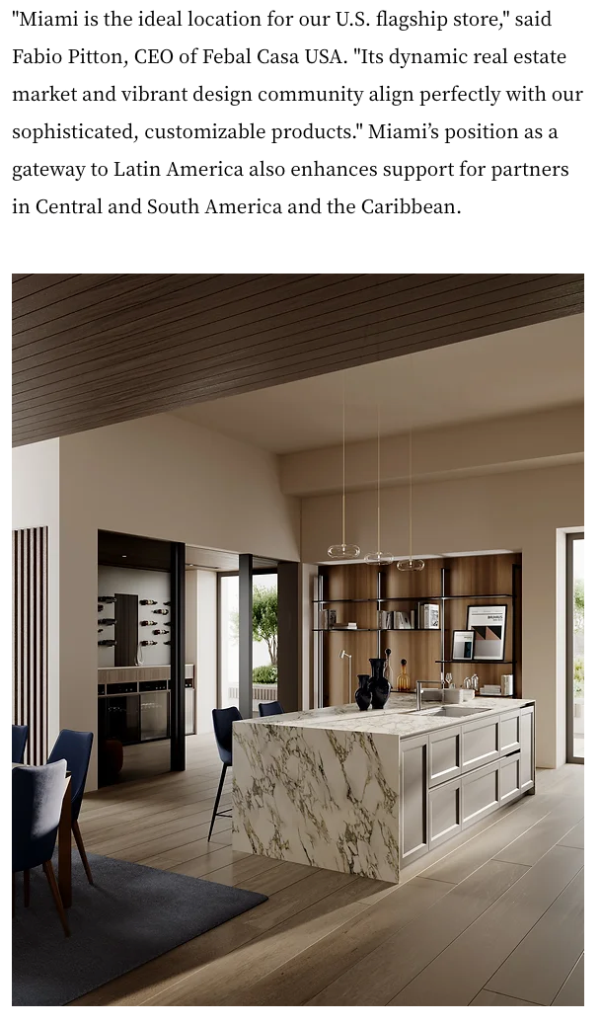
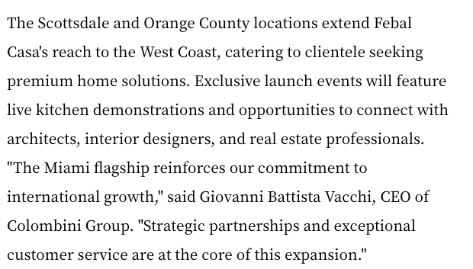

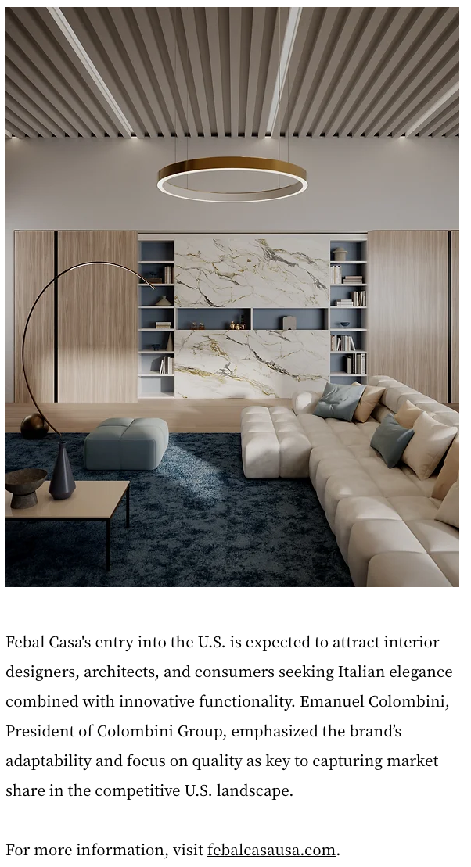

Media // South Florida Business Journal - November 7, 2024
- South Florida Business Journal: Colombian restaurant-club debuts 1st U.S. location in Miami Beach and more (UVM: 9,600,000) - November 7, 2024


