Febal Casa - Scottsdale

Editorial Coverage Clippings
Table of Contents
Social // Alyson Alconis - November 24, 2024 2
Social // Alyson Alconis - November 23, 2024 3
Social // Samantha Elizabeth - November 23, 2024 4
Social // Yliana Kolosseus-Glomski - November 23, 2024 5
Media // KSAV-TV (Broadcast) - November 21, 2024 6
Media // PR Newswire - November 21, 2024 7
Media // Arizona Foothills Magazine Online - November 18, 2024 9
Media // Scottsdale.com - November 15, 2024 12
Media // Phoenix Business Journal - November 14, 2024 14

Social // Alyson Alconis - November 24, 2024
- Alyson Alconis, @alyson.alconis Instagram Post (25,155 Followers) - November 24, 2025




Social // Alyson Alconis - November 23, 2024
- Alyson Alconis, @alyson.alconis IG Stories (25,155 Followers) - November 23, 2025

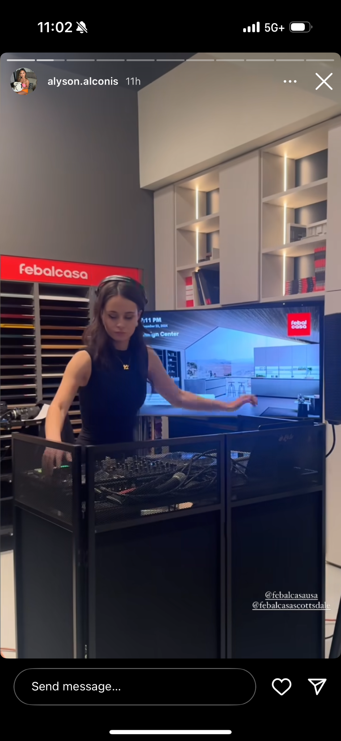

Social // Samantha Elizabeth - November 23, 2024
- Samantha Elizabath, @iamsamanthaelizabeth IG Stories (22,683 Followers) - November 23, 2025




Social // Yliana Kolosseus-Glomski - November 23, 2024
- Yliana Kolosseus-Glomski, @ykk.interiors IG Stories (2,025 Followers) - November 23, 2024




Media // KSAV-TV (Broadcast) - November 21, 2024
- KSAV-TV (Broadcast): Fox 10 Arizona Morning @ 9:45 am (Viewership: 887,543) - November 21, 2024
- KSAV-TV (Broadcast): Fox 10 Arizona Morning @ 9:55 am (Viewership: 887,543) - November 21, 2024



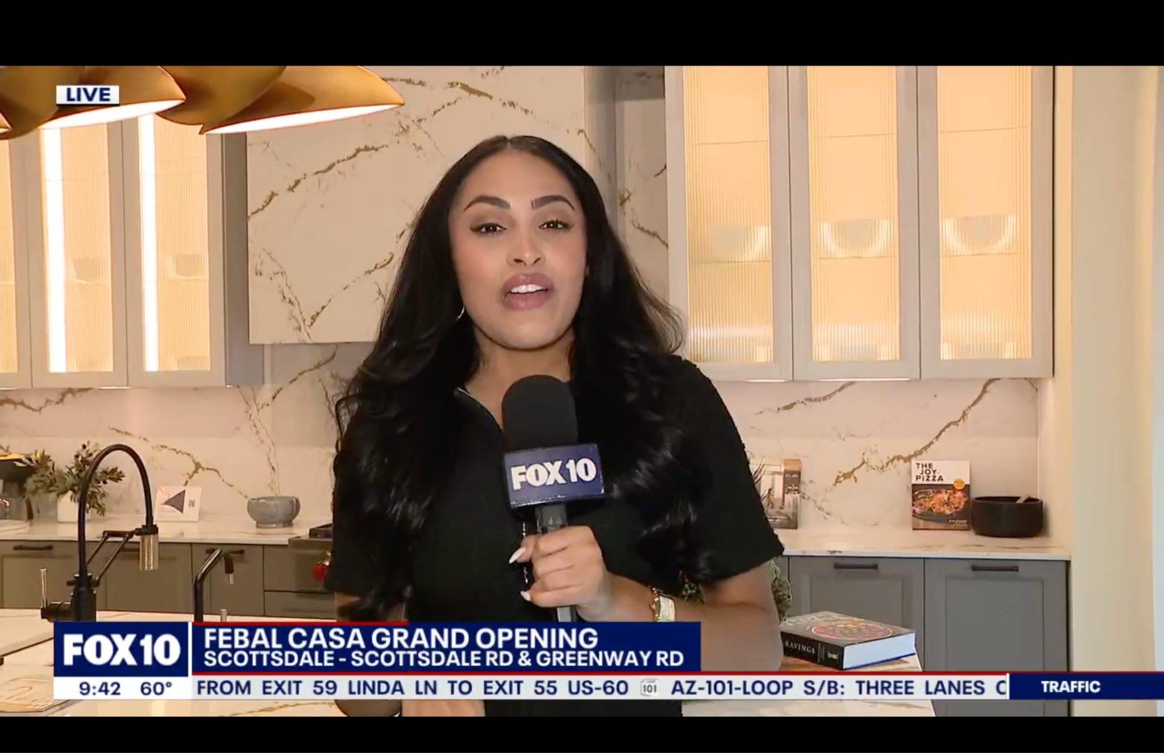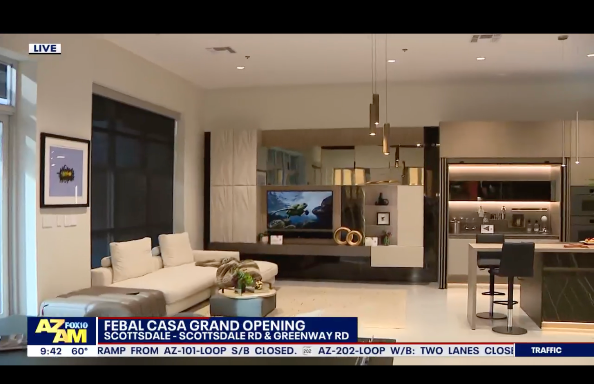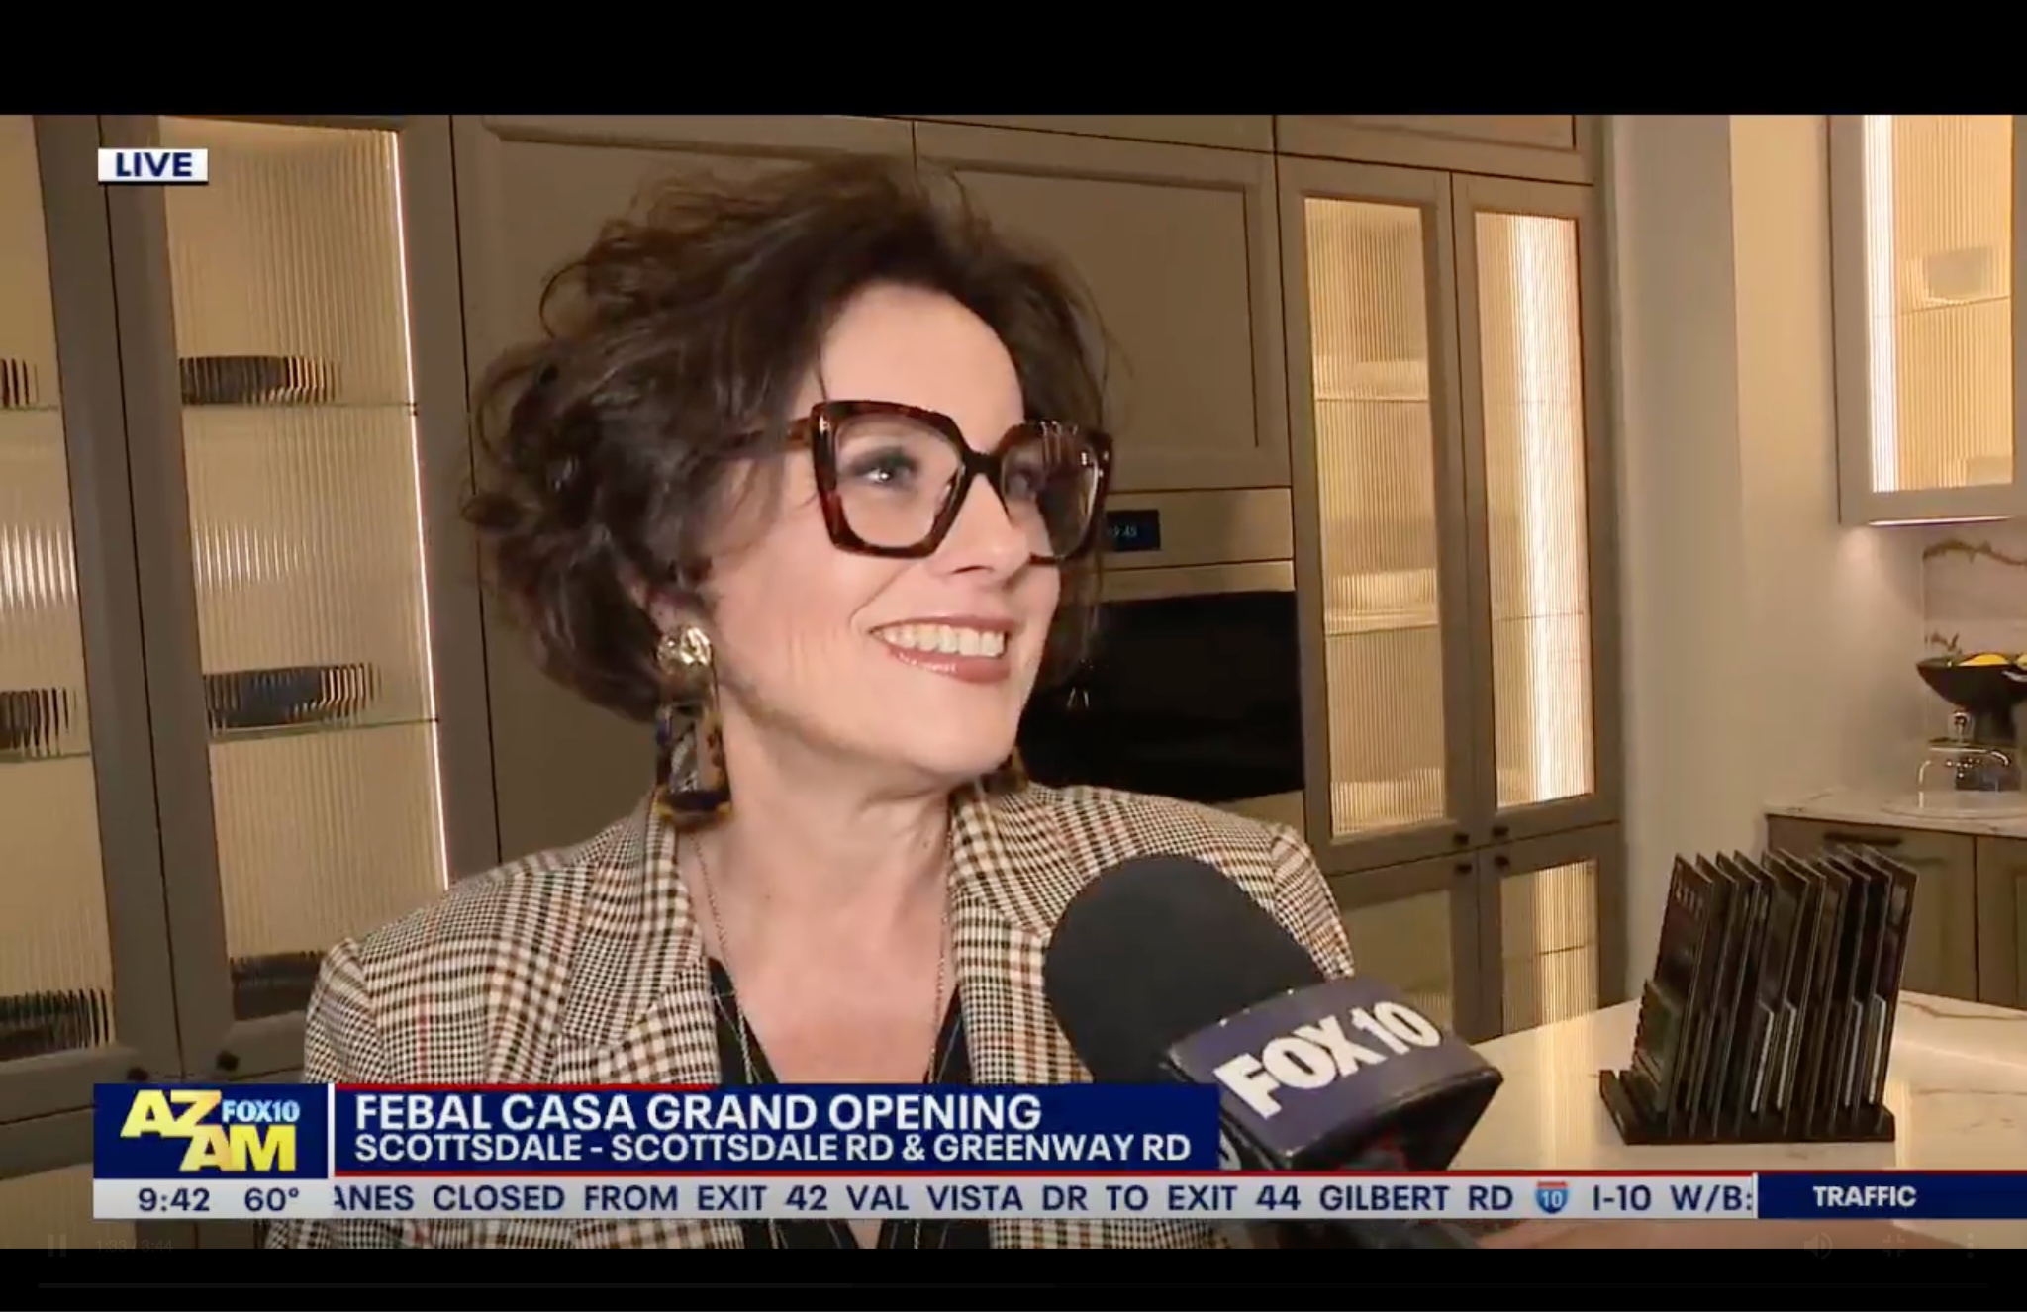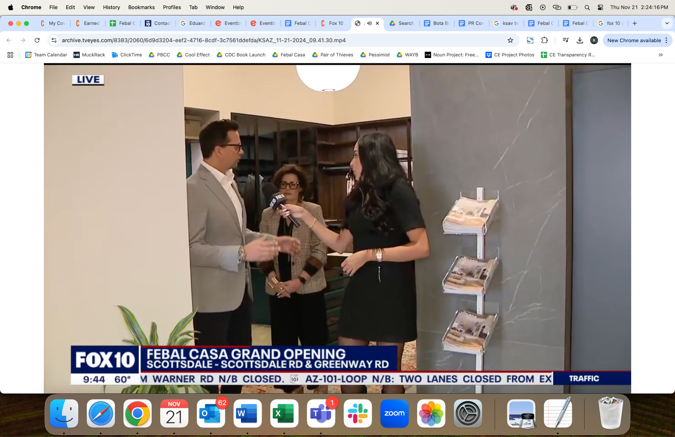
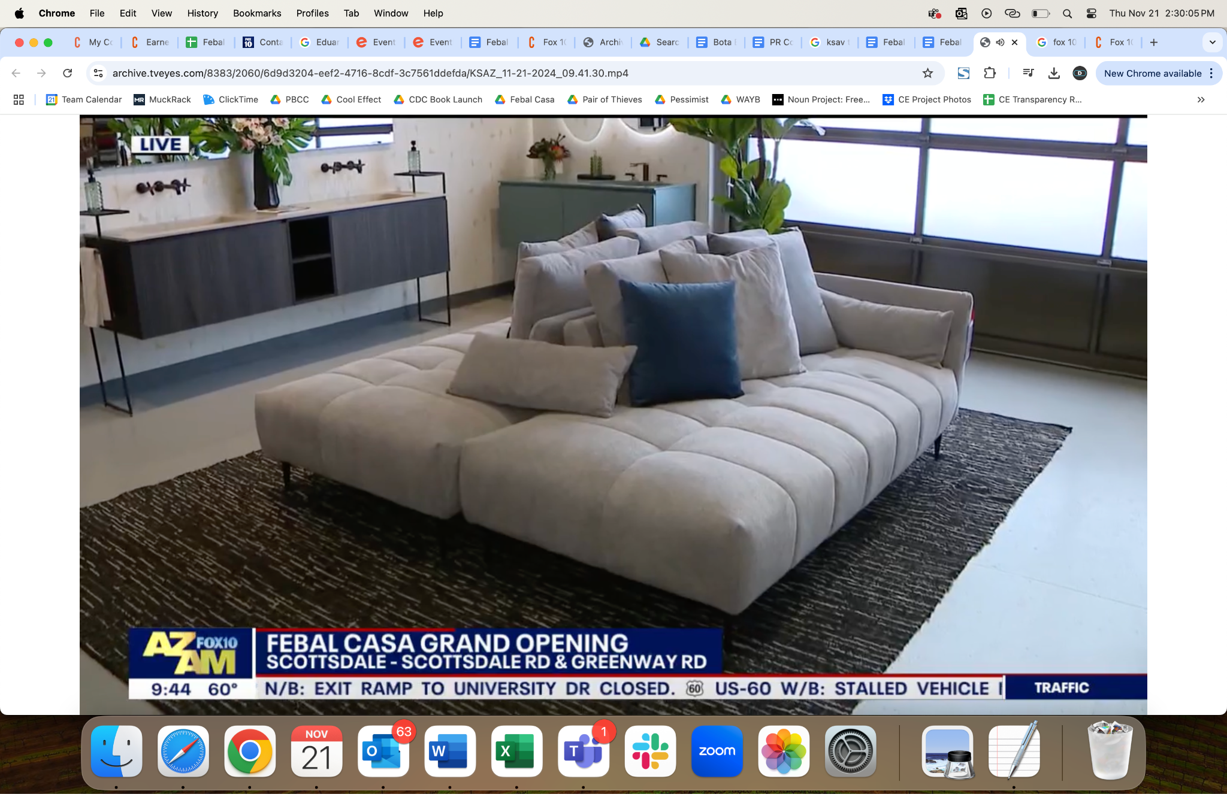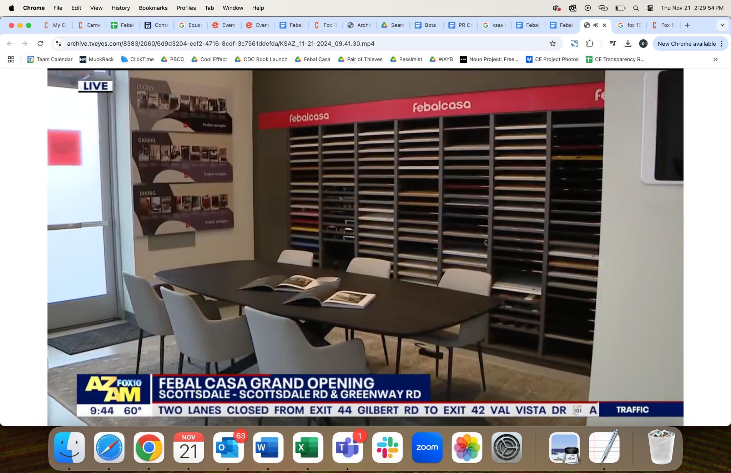

Media // PR Newswire - November 21, 2024
- PR Newswire: Febal Casa Enters U.S. Market with Flagship Store Opening in Miami and Outposts in Scottsdale and Orange County (UVM: 3,557,469) - November 21, 2024
  - Associated Press (UVM: 48,045,067)
  - Yahoo! Finance (UVM: 46,518,831)
  - Benzinga (UVM: 9,963,602)
  - StreetInsider (UVM: 399,664)

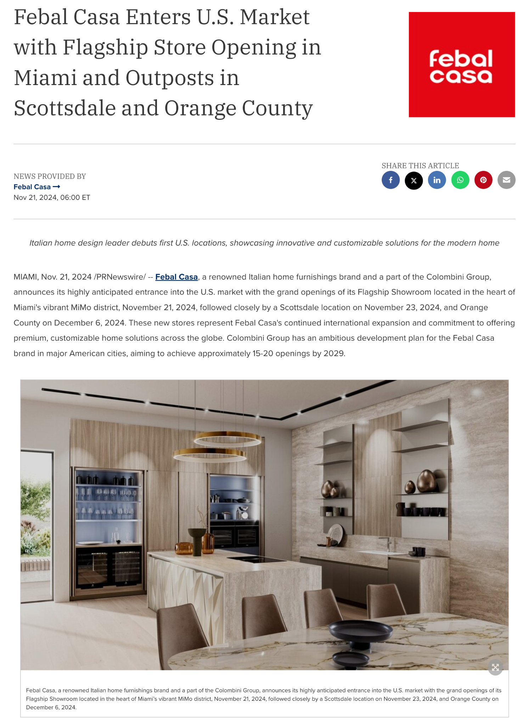
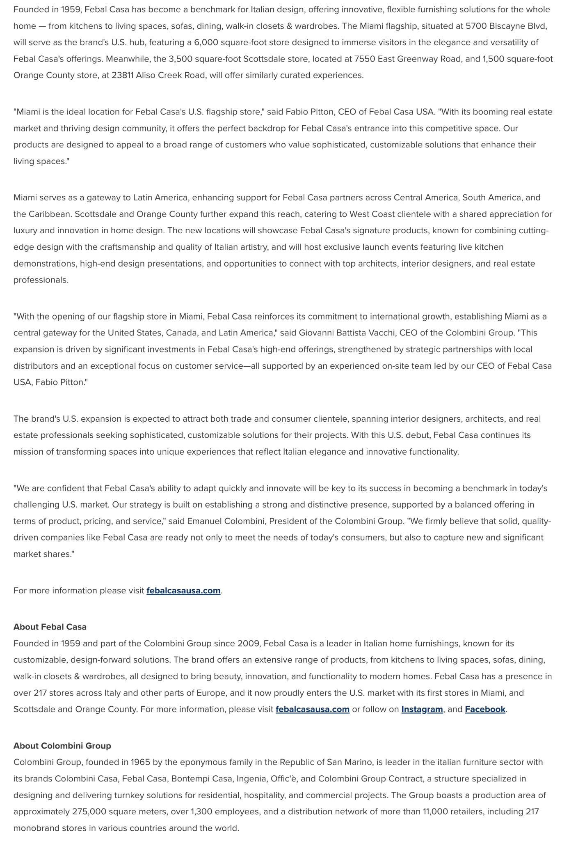

Media // Arizona Foothills Magazine Online - November 18, 2024
- Arizona Foothills Magazine Online: Febal Casa Brings Italian Elegance to the U.S. (UVM: 112,418) - November 18, 2024


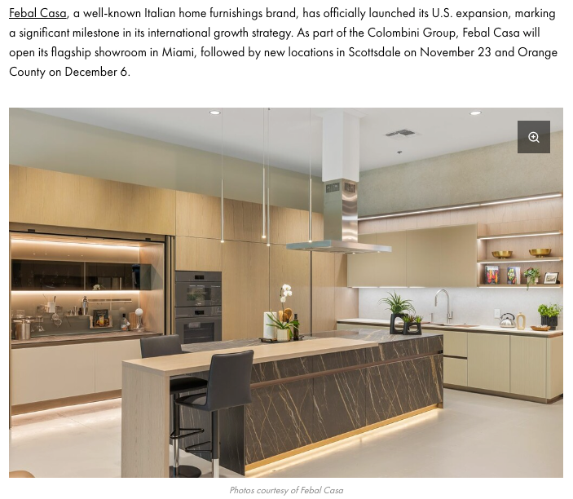
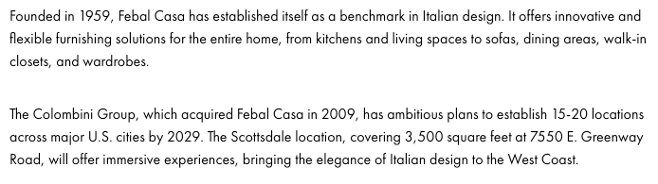
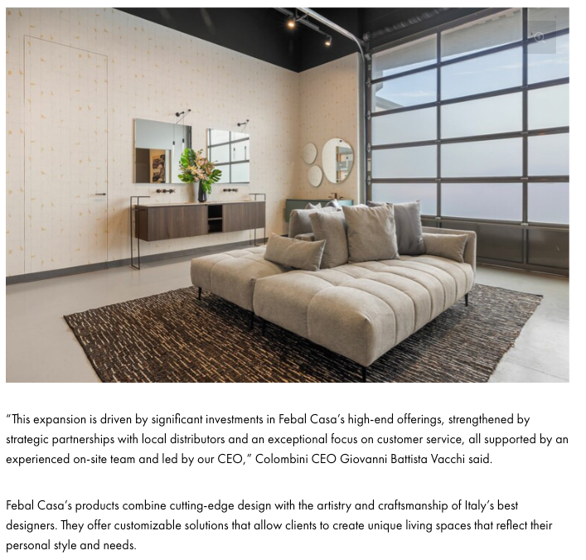
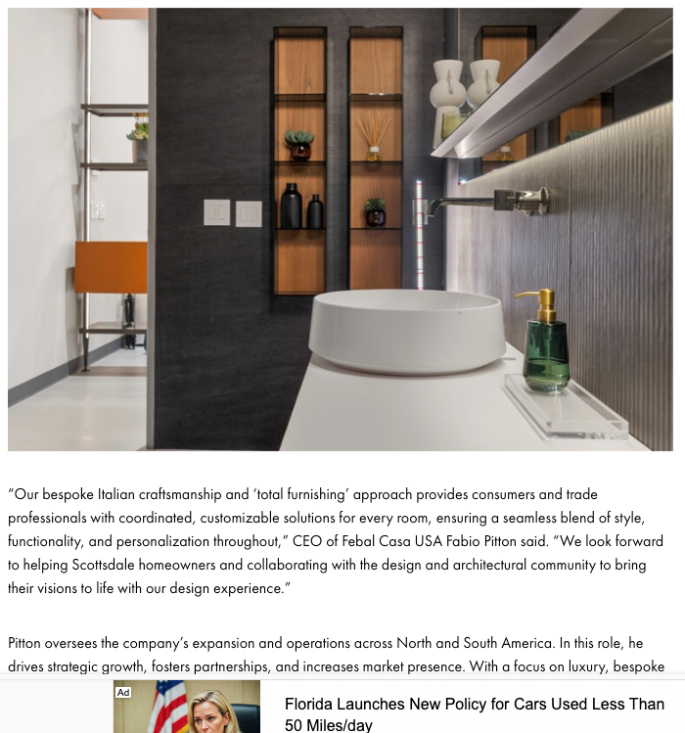
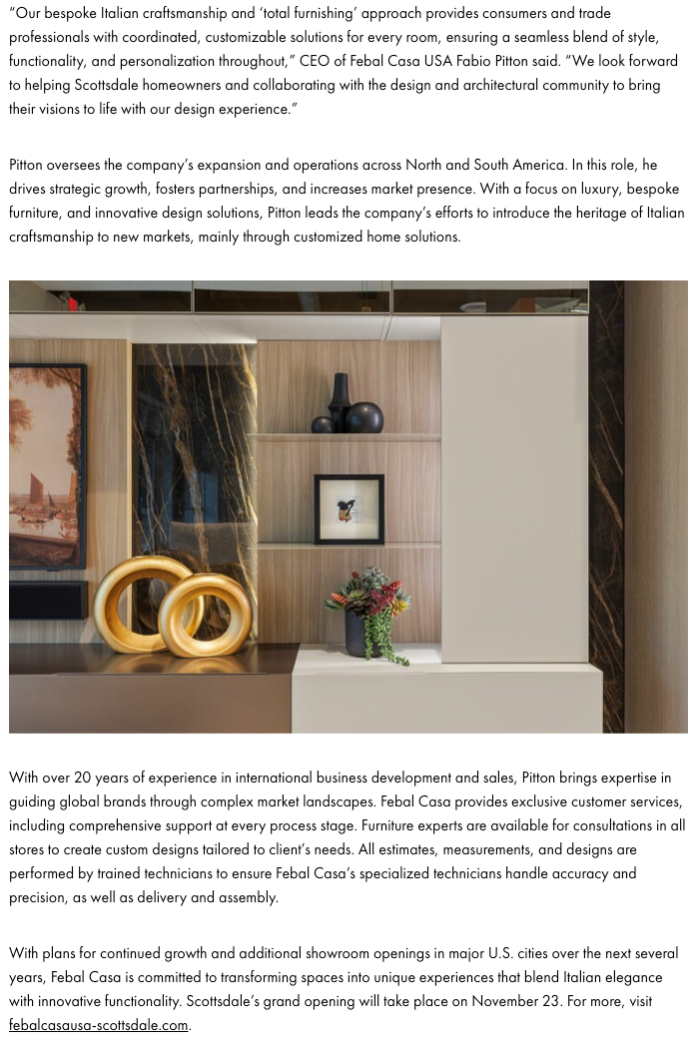

Media // Scottsdale.com - November 15, 2024
- Scottsdale.com: Italian Home Furnishings Brand Febal Casa to Open in Scottsdale Airpark (UVM: 17,224) - November 15, 2024



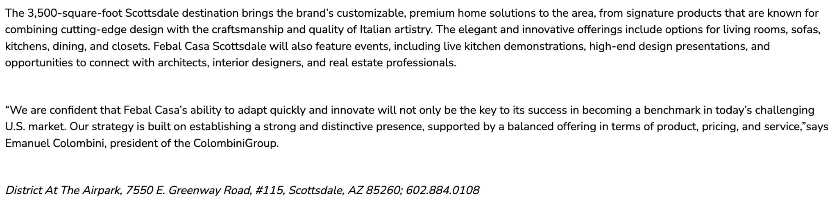
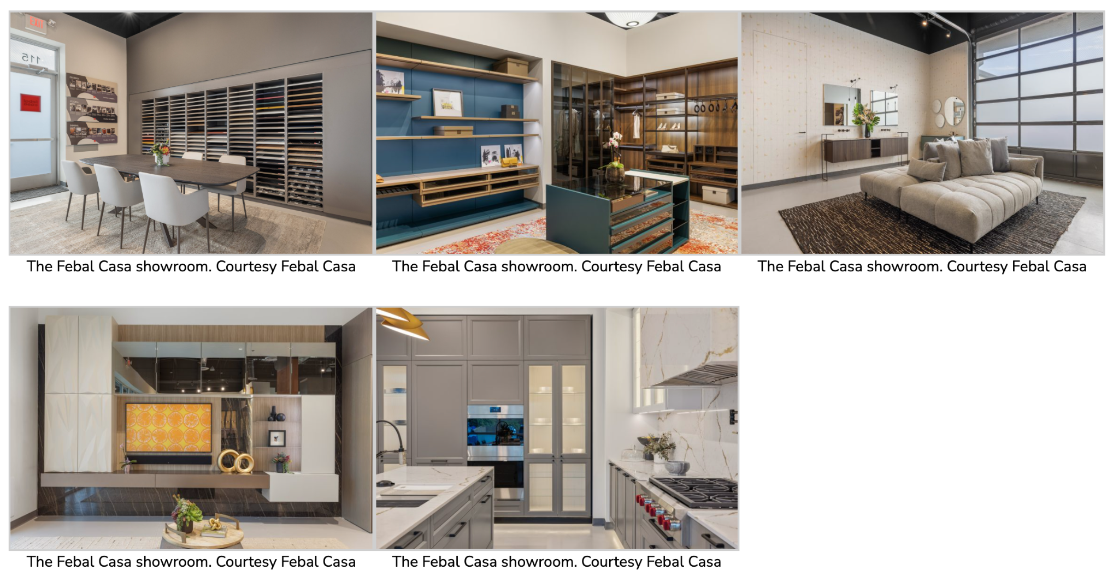

Media // Phoenix Business Journal - November 14, 2024
- Phoenix Business Journal: Dallas firm's Valley industrial portfolio keeps growing with Sky Harbor-area buy; plus 9 more deals to know (UVM: 5,260,040) - November 14, 2024



